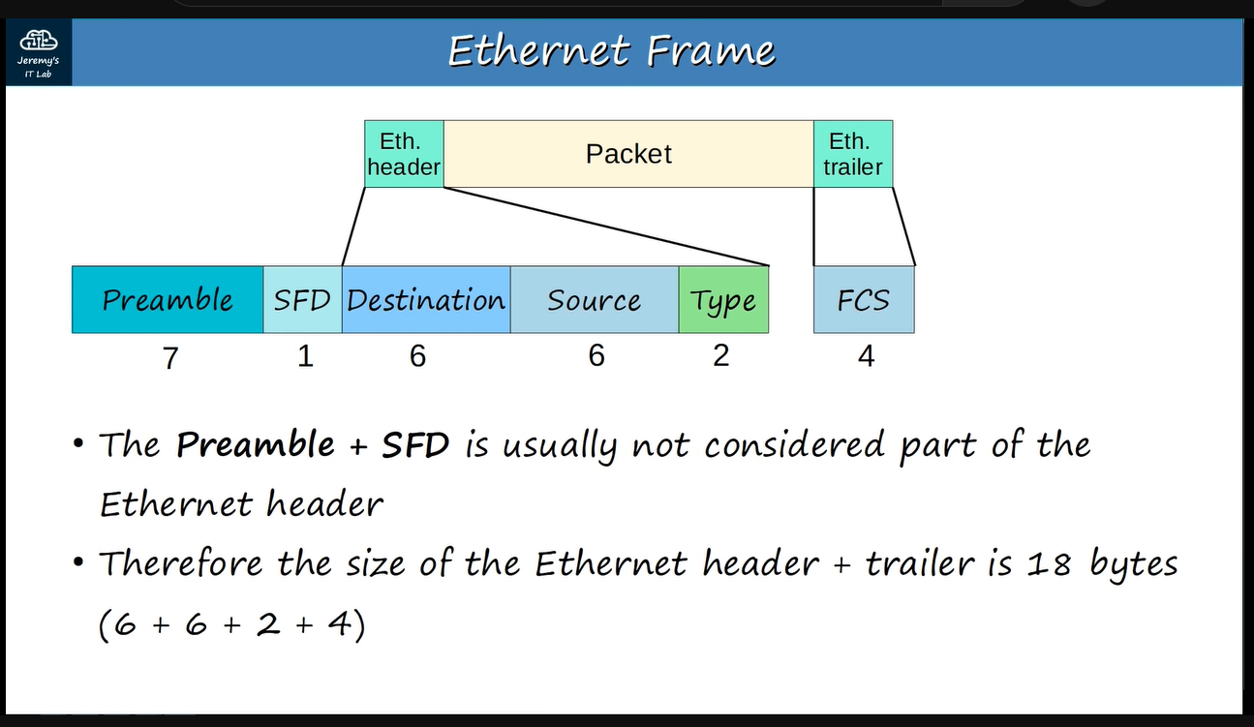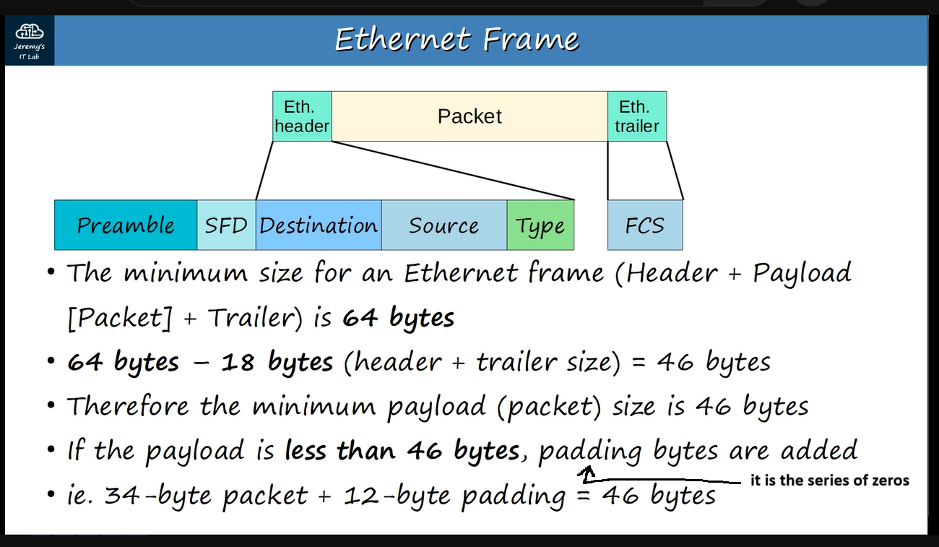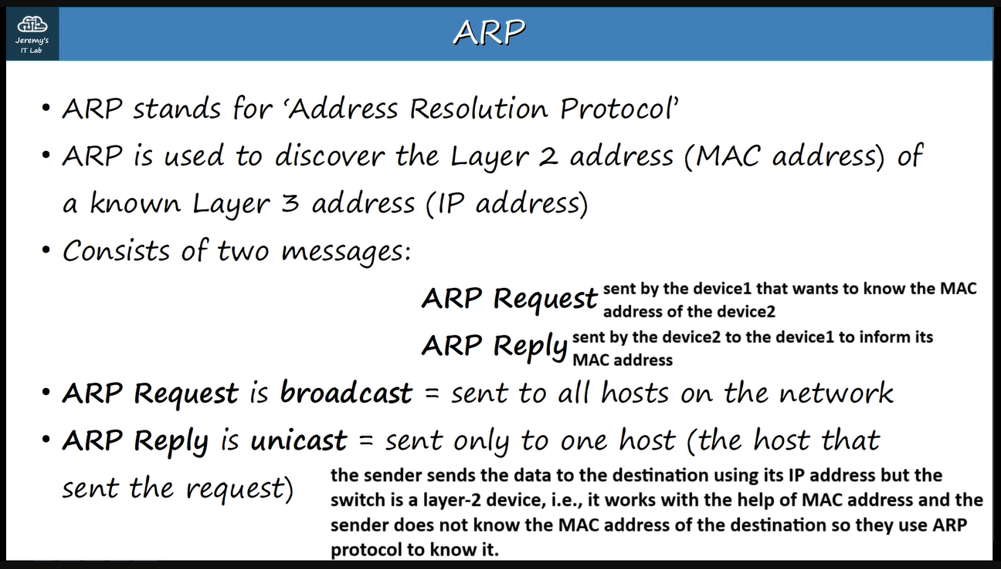

**the sender sends ARP-request frame to the destination and the receiver sends ARP-reply frame after receiving the ARP-request frame and after that the sender adds that information to its ARP-table which is used to store these IP address to MAC address associations.**

**After this process, the sender is able to send the actual frame to the destination.**

**ARP-request frame is “unknown unicast frame” & ARP-reply frame is “known unicast frame”.**

**PC1 sends ARP-request frame through SW1 but PC2 ignores it because the IP address in ARP-request frame does not match and the SW2 sends it to PC3 & PC4 and PC4 ignores it as PC2 ignores and PC3 accepts it because the IP address matches. As you can see in the following two photos.**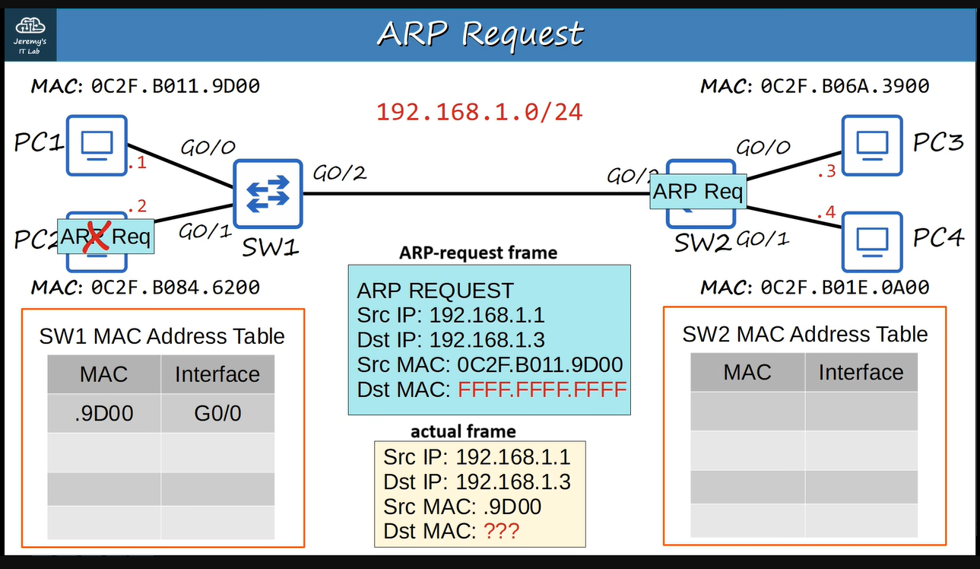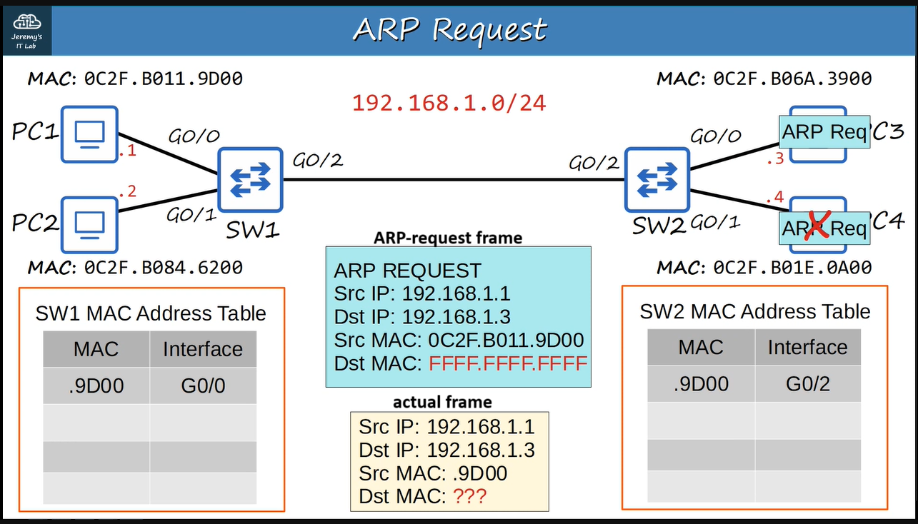

**FFFF.FFFF.FFFF is the destination MAC address used when a device wants to send ethernet frames to all other devices on the local network.**

**Then PC3 sends ARP-reply frame to the PC1 directly through SW1 & SW2 without having to broadcast the ARP-reply frame. As you can see in the following two photos.**

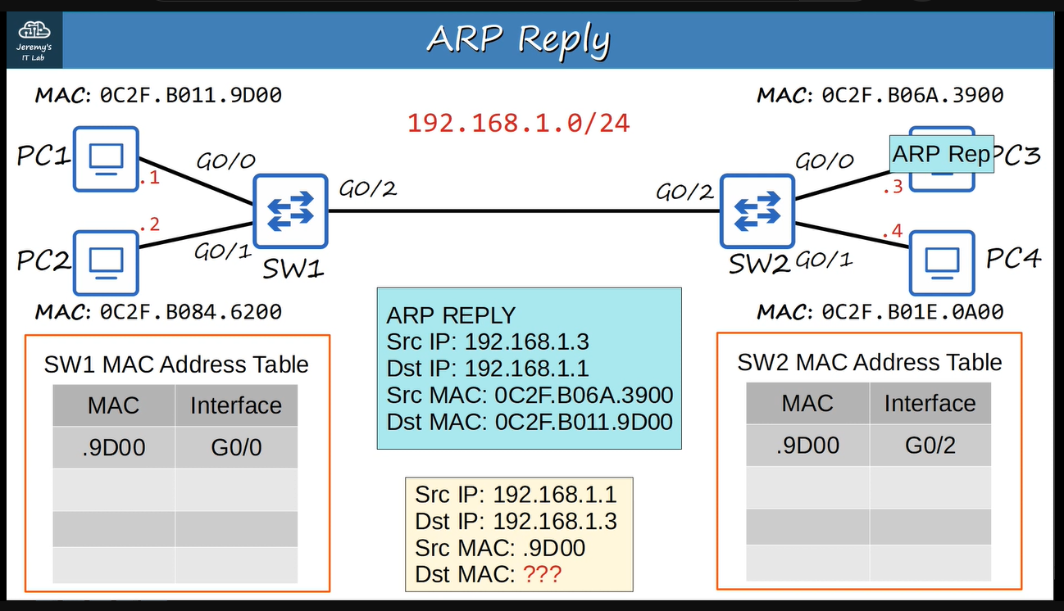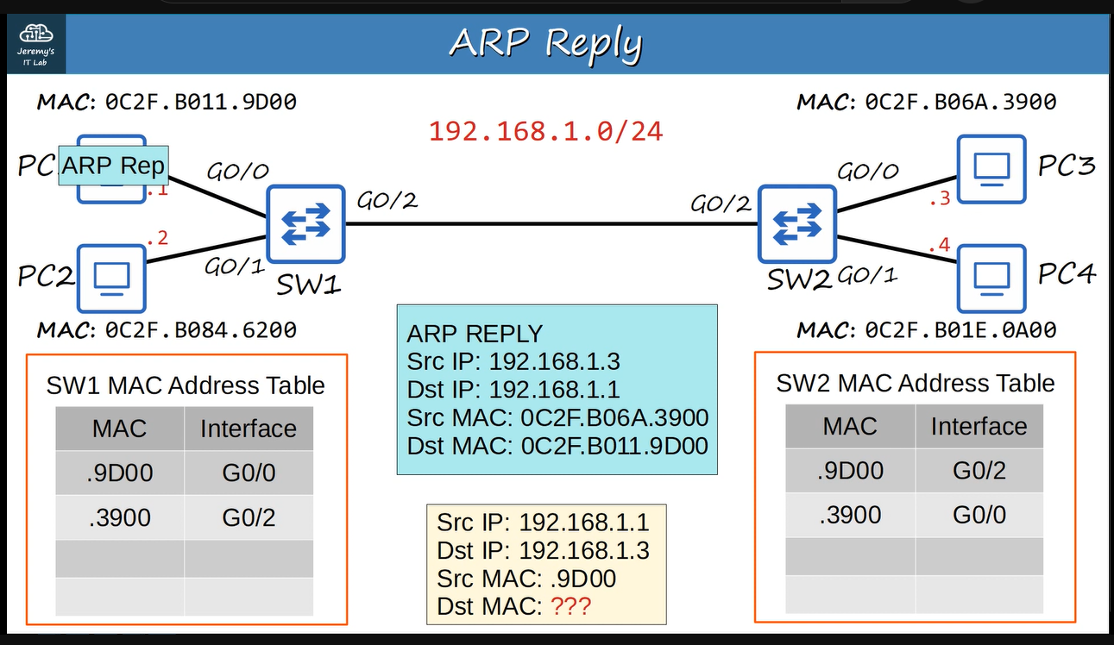

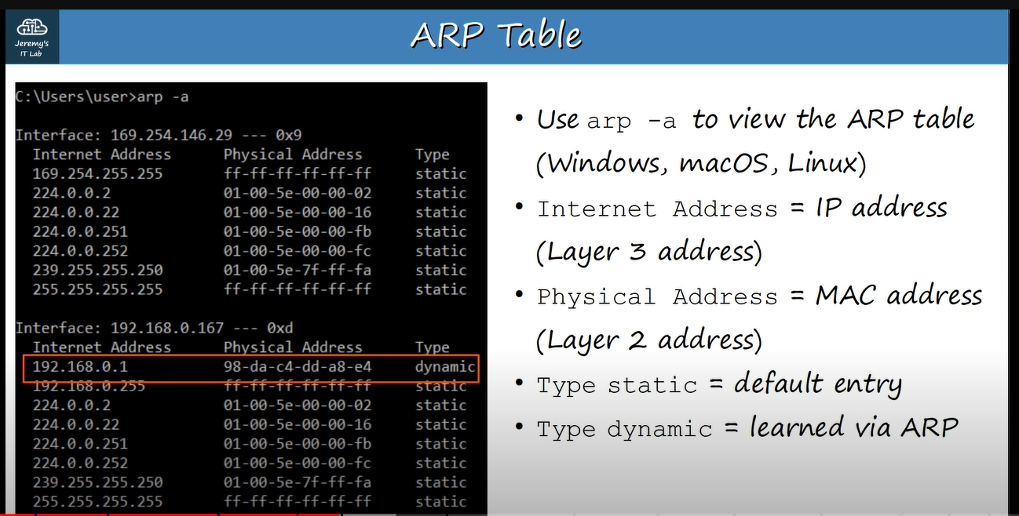

**To show the ARP-table in cisco CLI: command 🡪 show arp.**